Robotness:-
Principles:
- Define steady state (normal metrics)
- Hypothesize: "System will handle pod failure"
- Inject failure
- Observe: Did steady state hold?
Tools:
- Chaos Monkey (Netflix) — kills random instances
- Litmus (K8s native) — pod/node/network chaos
- AWS Fault Injection Service — AWS-managed chaos
- Gremlin — enterprise chaos platform
- Toxiproxy — network fault injection
Chaos engineering: Kill random pods, nodes, network links
Fault injection: Introduce latency, packet loss, disk failures
Kill CRE pod with SIGKILL, measure recovery < 77s
Check zero coredumps, zero unexpected restarts

Stability:-
Load testing vs stress testing vs soak testing?
- Load testing: Expected load. "Can we handle 100K sessions?" → Verify SLOs are met
- Stress testing: Beyond expected load. "What happens at 200K sessions?" → Find breaking point
- Soak testing: Normal load for long time. "Run 12 hours at 80% capacity" → Find memory leaks, resource exhaustion
High Availability & GeoRedundancy
Explain Active/Standby vs Active/Active
Active/Standby: One cluster handles traffic, other is idle but synced. Switchover on failure. Simpler but wastes resources.
- Cluster A (ACTIVE) ← all traffic
- Cluster B (STANDBY) ← synced, no traffic
Active/Active: Both clusters handle traffic. More capacity but complex (data consistency, conflict resolution).
- Cluster A ← 50% traffic
- Cluster B ← 50% traffic

data replication work between clusters (for HA )?
- Real-time sync: Every session create/modify/delete is replicated
- Bulk sync: Full database sync after switchover (catch up)
- Measured by:
pckvdbrdr_bulk_sync_percent = 100 (all data synced)
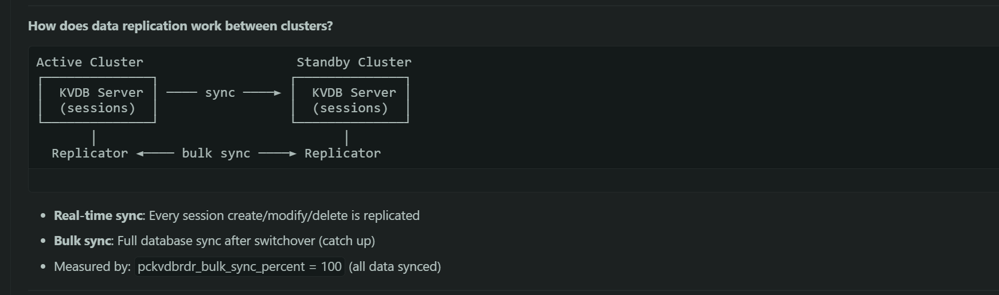

Monitoring & Observability
Metrics vs Logs vs Traces?
- Metrics: Numbers over time. "CPU is 75%", "500 requests/sec". Cheap to store, good for alerting.
- Logs: Text events. "Error: connection refused at 10:23:45". Detailed but expensive to store/search.
- Traces: Request journey across services. "Request took 200ms: 50ms in service A → 100ms in service B → 50ms in DB". Good for debugging latency.
Recorded every events, proper tracing backend meaningful metric(custom/standard).
- Pull-based: Prometheus scrapes targets (not push)
- TSDB: Time-series database, efficient for metrics
- PromQL: Query language for metrics
Counter vs Gauge vs Histogram?
- Counter: Only goes up. Resets on restart. Use for: total requests, total errors.
- pcuppep_pfcp_received_messages_total = 1,234,567
- Gauge: Goes up and down. Use for: current CPU, active sessions, temperature.
- pcupdp_cpu_load_15s_percent = 72.5
- Histogram: Distribution of values in buckets. Use for: request latency.
- http_request_duration_seconds_bucket{le="0.1"} = 500
- http_request_duration_seconds_bucket{le="0.5"} = 900
http_request_duration_seconds_bucket{le="1.0"} = 950
Alerting:-
Bad alerts: "Disk 50% full" (not urgent), "Pod restarted" (K8s handles it), "CPU spike for 10 seconds" (transient).
RED (for request-driven services):
- Rate: requests/sec
- Errors: failed requests/sec
- Duration: latency per request (P50, P95, P99)
USE (for resources):
- Utilization: % of resource used (CPU 75%)
- Saturation: queue depth, waiting work
- Errors: error count

What is SLI, SLO, SLA?
- SLI (Service Level Indicator): The metric. "99.95% of requests succeed"
- SLO (Service Level Objective): The target. "We aim for 99.99% success rate"
- SLA (Service Level Agreement): The contract. "If we drop below 99.9%, customer gets credit"

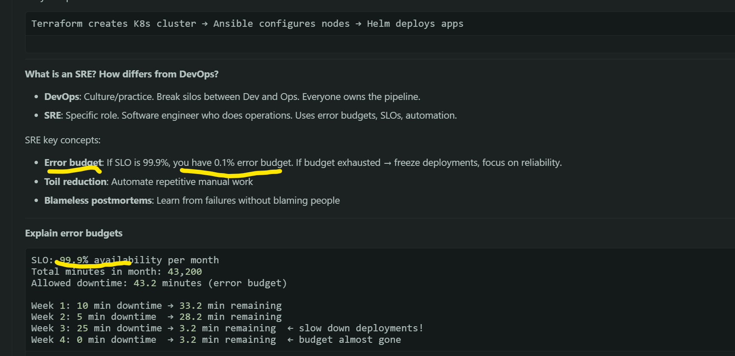

What is RPO and RTO?
- RPO (Recovery Point Objective): How much data can you lose? "Last 5 minutes of data"
- RTO (Recovery Time Objective): How fast must you recover? "Within 15 minutes"
- RPO: pcuppep_pfcp_total_sessions on all clusters differ by less than 0.1% — almost zero data loss
- RTO: bulk_sync_duration_seconds < 300(5 min), recovery time is at most 77 seconds

How does data replication work between clusters?
- Real-time sync: Every session create/modify/delete is replicated
- Bulk sync: Full database sync after switchover (catch up)
- Measured by:
pckvdbrdr_bulk_sync_percent = 100 (all data synced)


